# Configure Okta SSO on your local development environment

steps to configure Okta SSO on your local development environment

1. Go to [okta.com](http://okta.com)
2. Click on Try Okta (for free trials)



1. Enter the signup information
2. After entering the sign up information, Okta will send email with the newly created account credentials
3. Login using the link sent in the email with the credentials provided
4. After logging in, on the navbar, click on Applications

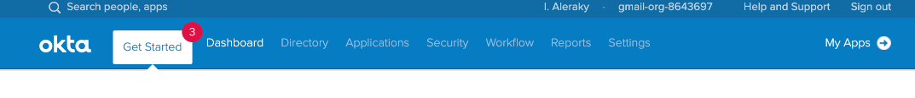

1. On the top left corner, click Add Application

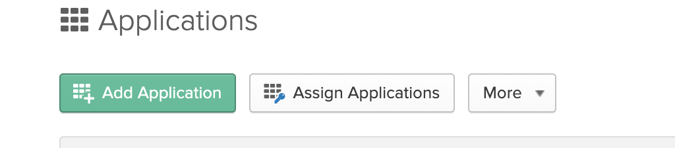

1. On the top right corner, click Create New App



1. from platform choose web and from Sign on method choose SAML 2.0

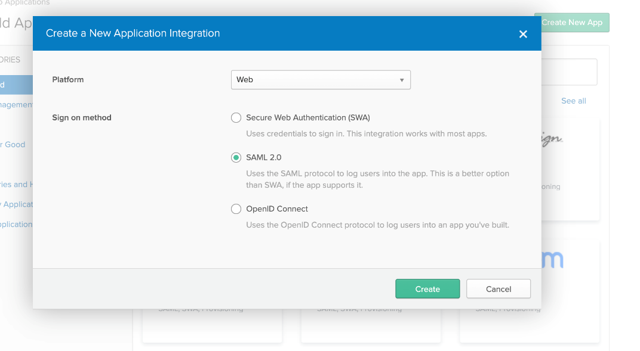

1. click on Create
2. enter the App name, then click next

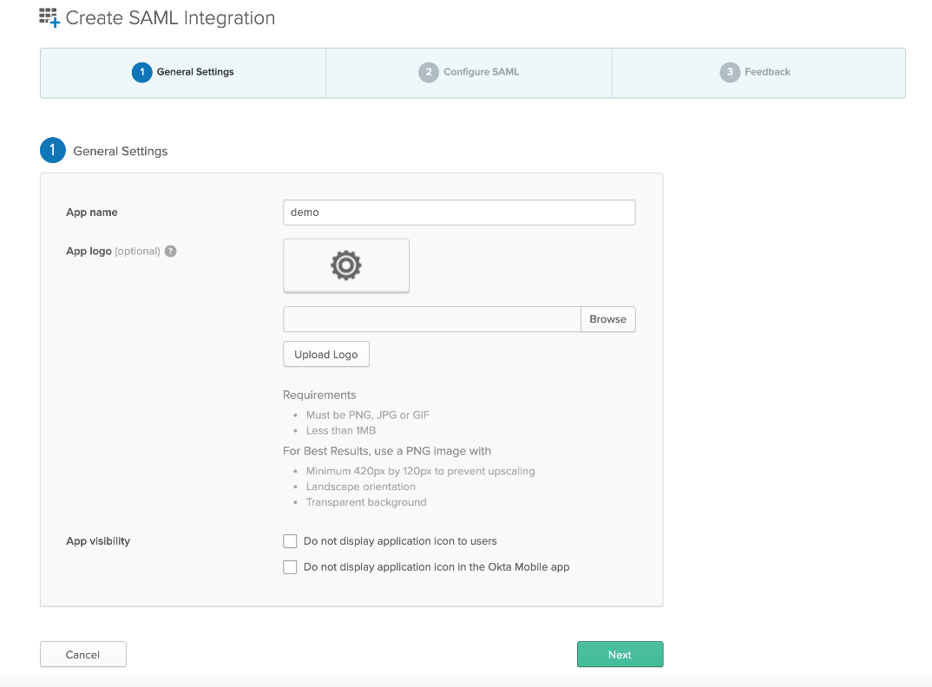

1. in **Single sign on URL**, enter the URL of incorta that will redirect to okta which is <URL>/incorta/!<tenantName>/, example <http://localhost:8080/incorta/!demo/>
2. **Note: do not forget to add backslash “/“ at the end of the URL**
3. activate **Use this for Recipient URL and Destination URL** checkbutton
4. in **Audience URI (SP Entity ID)** enter the same value of **Single sign on URL** like the following image.

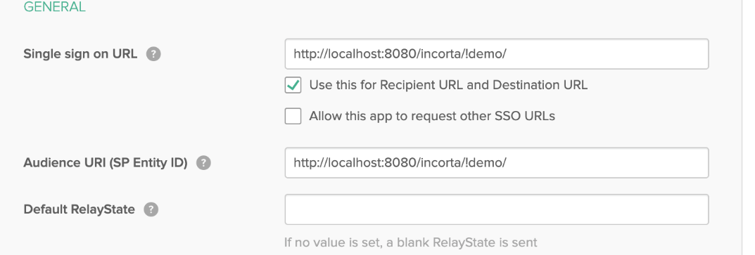

1. add the user mapping from okta to Incorta, So in Name enter **loginName** and in Value enter **user.email**

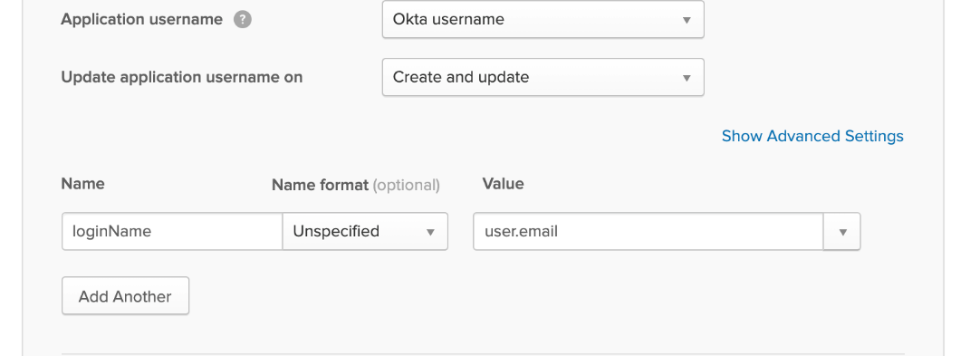

1. check the information are like the following image then click next

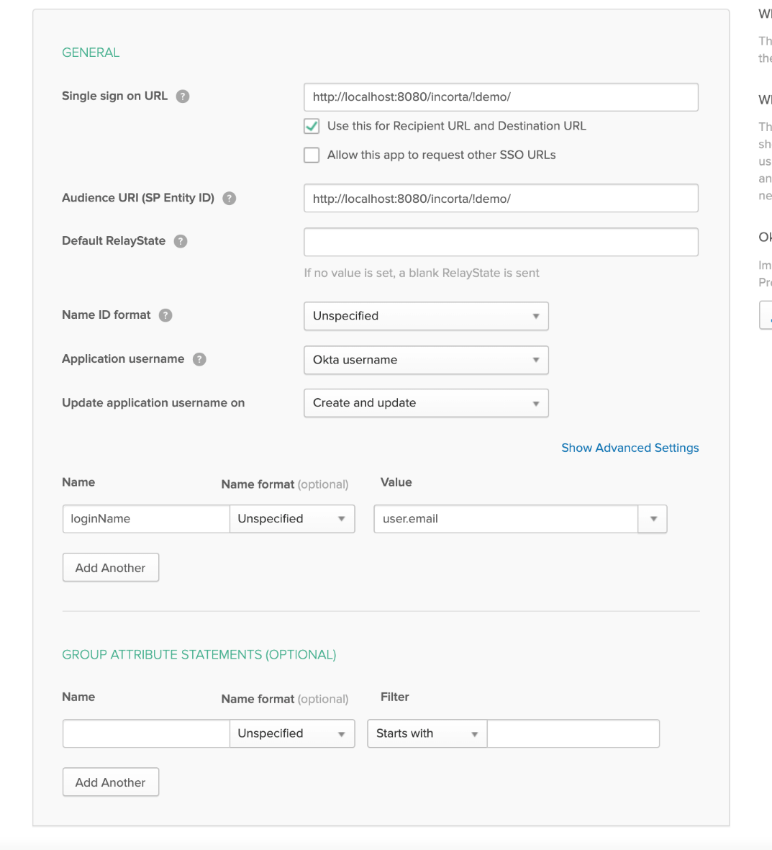

1. choose **I'm a software vendor. I'd like to integrate my app with Okta** then click Finish

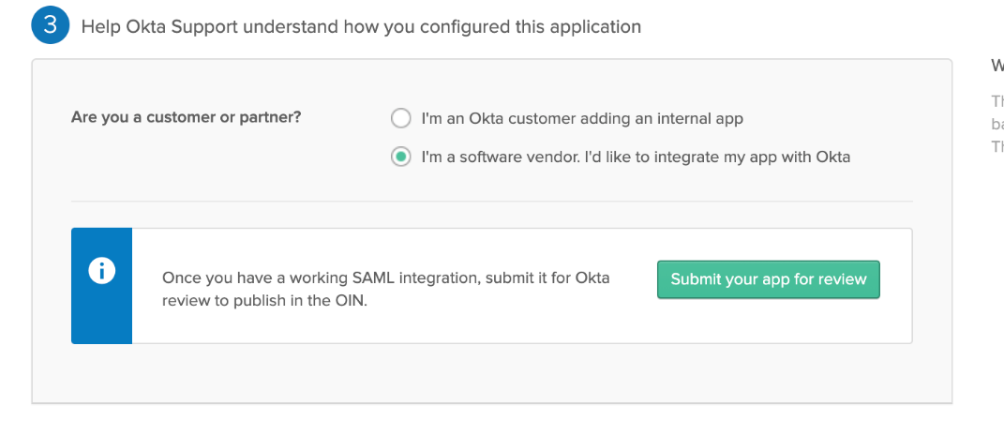

1. in the Sign On tab, click on **Identity Provider metadata**, which will open a new tab in the browser containing XML

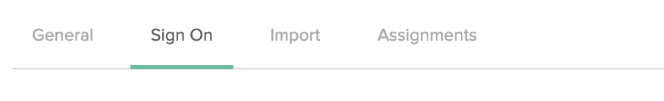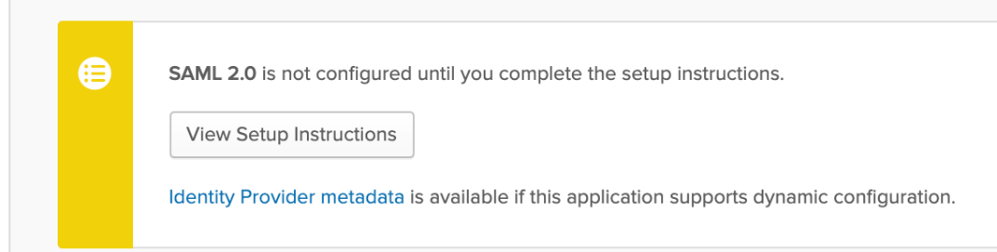

1. right click on any free space and select save as, then click save to download the XML

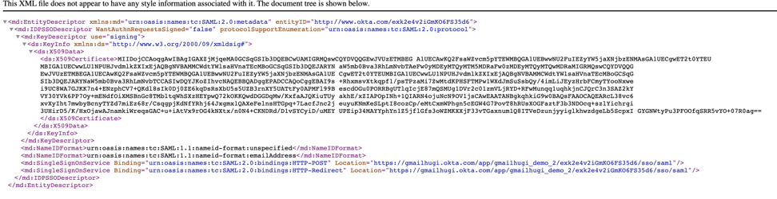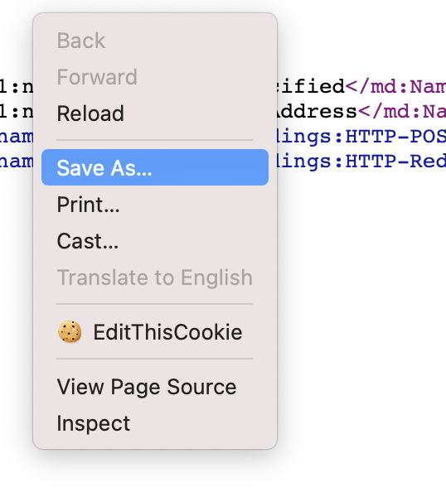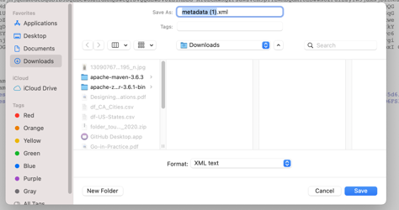

1. go to the page of the application you created, then click on the Assignments tab

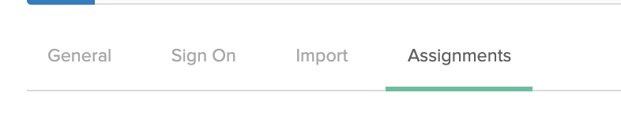

1. click on Assign, then assign to people

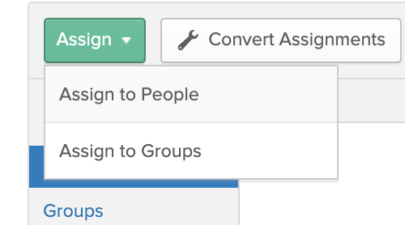

1. choose the users assigned to this application by clicking assign

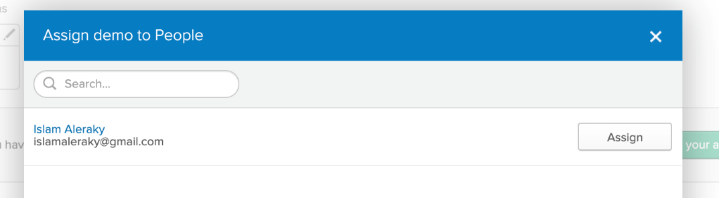

1. click Save and Go Back, then click Done

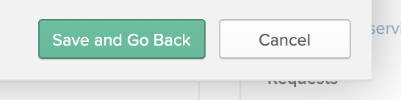

1. **Note: the user email in Okta should match the loginName in incorta**
2. enable SSO property for the tenant by setting the value of **sso-login-enable** key property (in incorta database table TENANT_CONFIG) that is related to the tenant used in okta to be true



1. open eclipse and open the servers tab

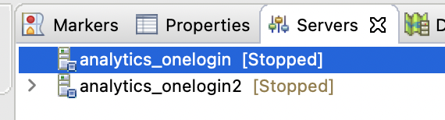

1. right click on any empty space and choose new then choose server

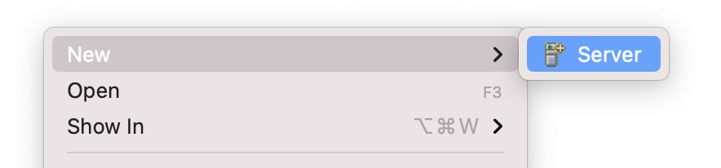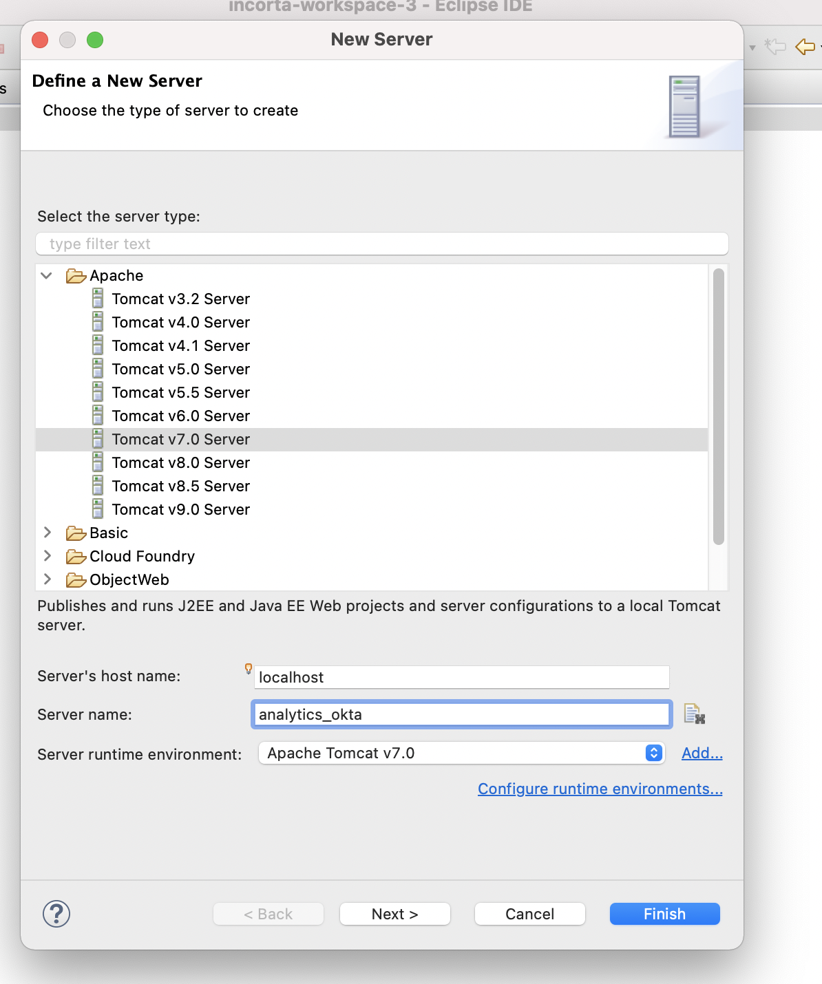

1. choose incorta.server and click add, then click Finish

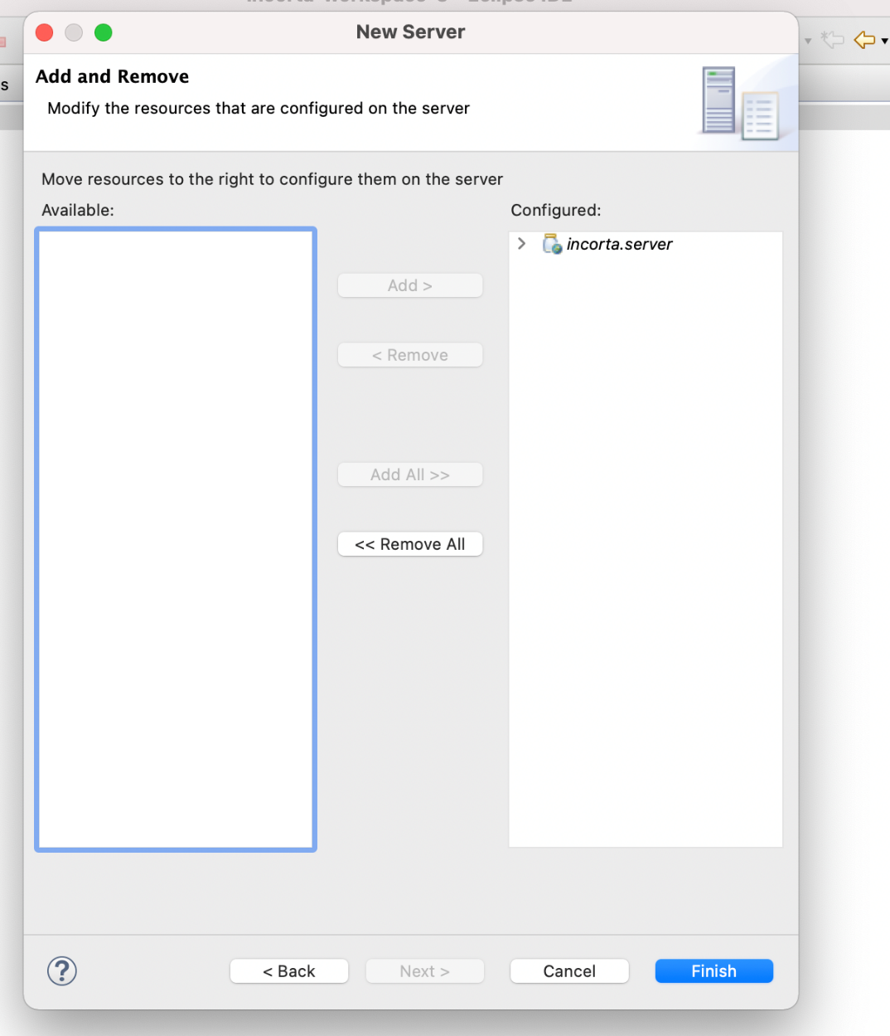

1. double click on the server you created

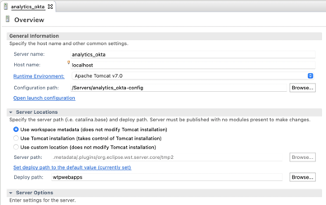

1. change the configuration path to the path of the server’s configuration
2. click on Use custom location in server locations and change the server path.
3. save the changes
4. click on Open launch configuration

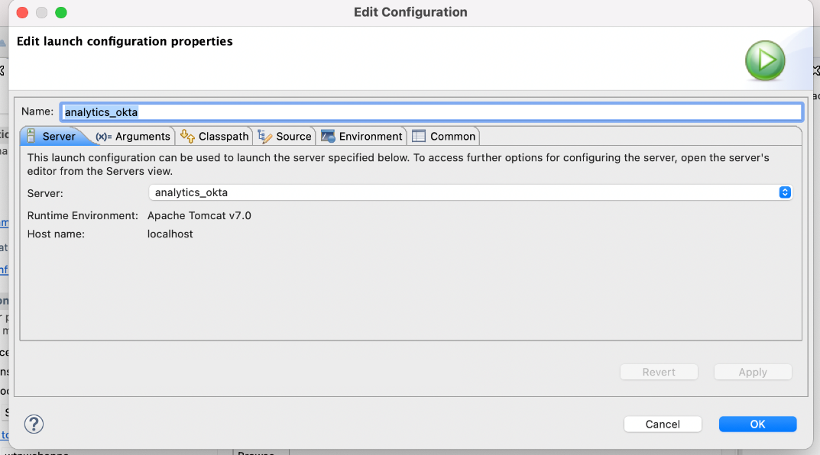

1. go to Classpath and add the following two jars
   1. mysql-connector-java (in case of using mysql)
   2. commons-codec
2. go to Arguments then add the following lines in VM arguments% -Djava.util.logging.manager=org.apache.juli.ClassLoaderLogManager -Dmax.off.heap.memory=100 -Dengine.offheap=true

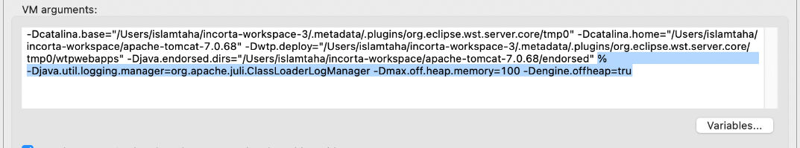

1. you can also refer to the following document: [/wiki/spaces/INC/pages/18448391](https://incorta.atlassian.net/wiki/wiki/spaces/INC/pages/18448391)
2. click apply, then click ok
3. open the server configuration folder then open server.xml
4. add the following as Valve in the server.xml  
   <Valve className="com.incorta.sso.valves.OktaValve"

confFilesMap="TENANT_NAME=ABSOLUTE_PATH,TENANT_NAME2=ABSOLUTE_PATH2"

LoggingEnabled = "true"

/>

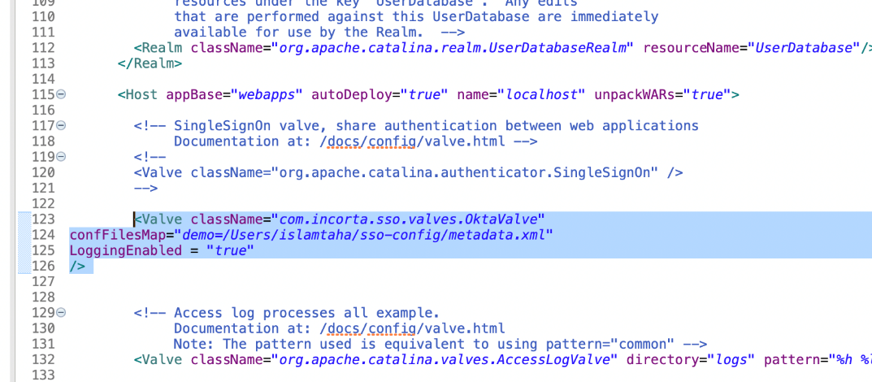

1. open okta metadata xml file that we downloaded earlier and add the following tags between md:EntityDescriptor tag:   
   <configuration>  
   <default><http://www.okta.com/exk2dy7f8xbKMqTG05d6</default>>  
   <applications>  
   <application>  
   <md:EntityDescriptor>  
   </md:EntityDescriptor>  
   </application>  
   </applications>  
   </configuration>  
     
   also make sure that the URL in the default tag should be the same as the entityId in <md:EntityDescriptor>  
   So eventually your xml folder should look something like this:

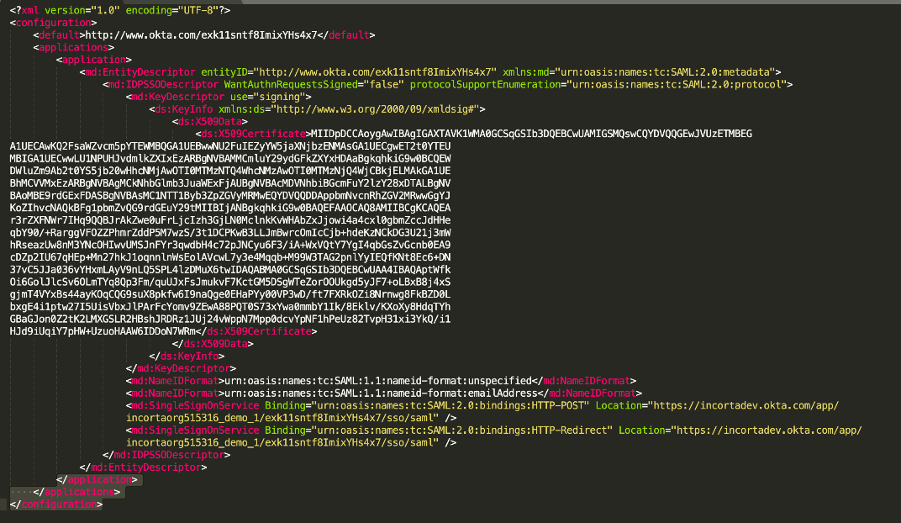

1. now double click on the server and click on Open launch configuration, then choose the Classpath tab  
   , then click on Add external jars, navigate to Tomcat installation directory then include all the jars inside lib folder except tomcat7-websocket.jar and websocket-api.jar

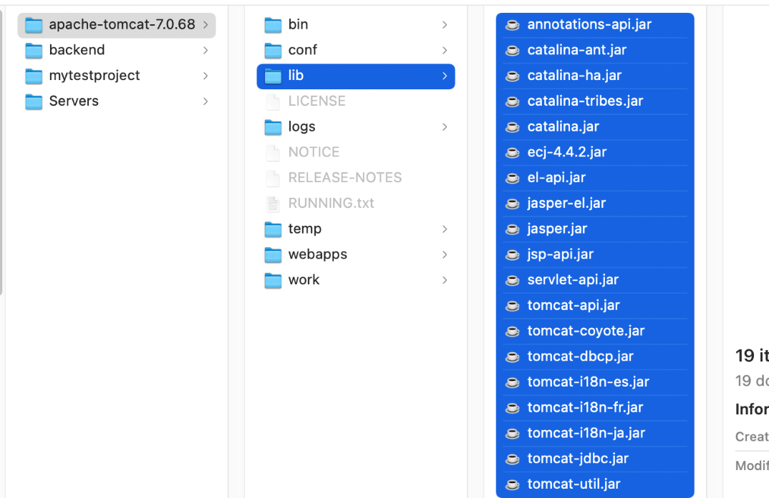

then click on add projects, and add incorta.addons in the classpath, then click ok

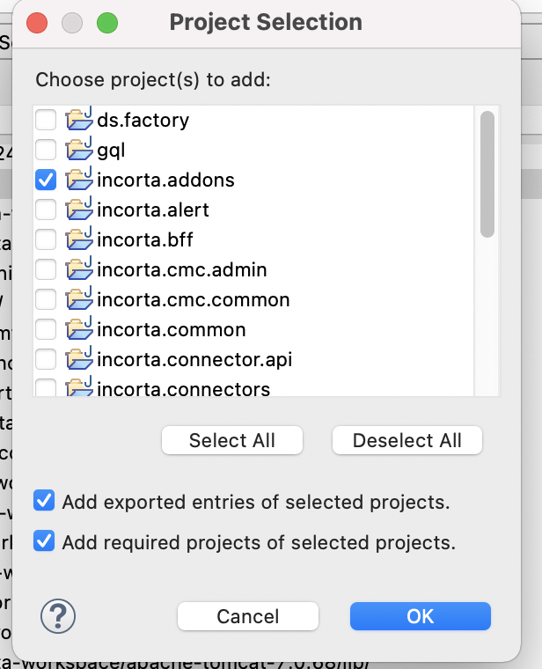

then click on add jars, then add the jars in the following image from lib/Okta

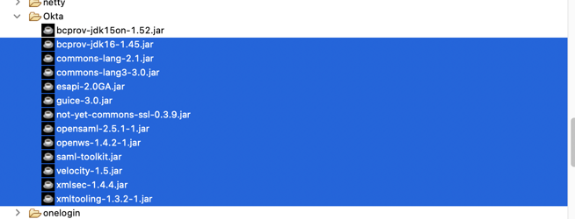

1. add slf4j-api-1.7.25.jar from lib/slf4j and commons-logging-1.1.13.jar and commons-collections-3.2.1.jar from lib/apache and joda-time-2.1.jar from lib/joda
2. make sure that the classpath contains the following dependencies in the same order

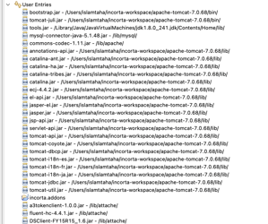

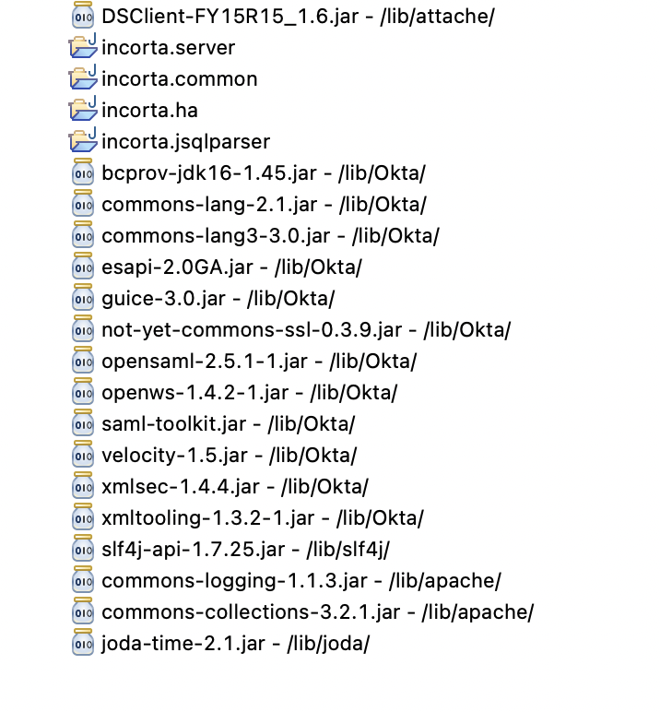

1. start the server, then login into Incorta and create a new user with type SSO and the loginName is the same user email in okta

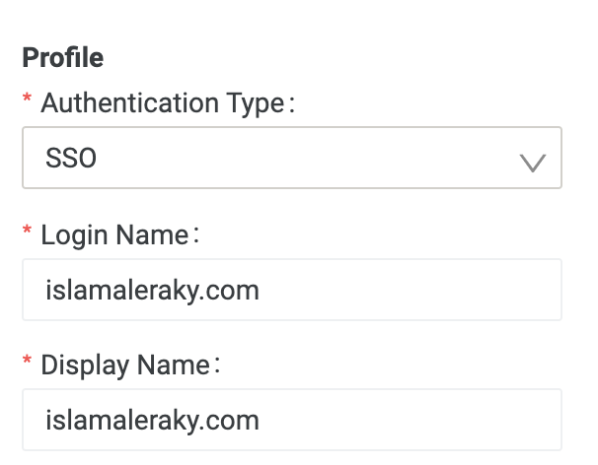

1. sign out of the current user and then type the localhost:8080/incorta/!<tenantName> for example localhost:8080/incorta/!demo and should be redirected to okta login page

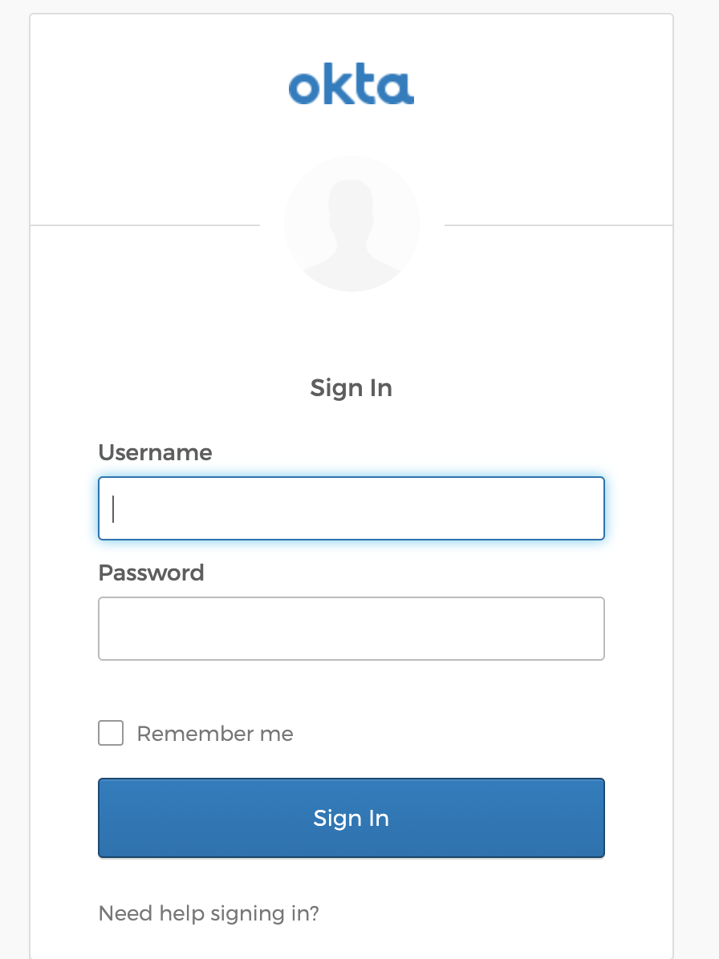

1. enter the username which is okta email and password and you shall be redirected to Incorta